# Demo Work Status

**(TT231 ITS WC)**

**The following lists are the Completed Screen implementations.**

1. Login Screen
2. Zone Selection Screen
3. CC2 Screen
4. CC2 Merge Screen
5. Individual Screen for
   1. Work order List Screen
   2. Incident IR List Screen
   3. Technical Alarm List Screen
   4. Environmental Monitor System List Screen
   5. Event List Screen
6. MRT Incident Creation Screen
   1. MRT Incident Screen
   2. MRT Incident Creation Screen
   3. MRT Incident Response Screen
7. Incident Creation Screen
   1. Incident (IR) Screen
   2. Incident (IR) Creation Screen
   3. Incident (IR) Response Screen
8. Even Creation Screen
   1. Event Creation Screen
   2. Event Response Screen

**I am working on the following list:**

1. Work Order and Technical Alarms in CC2 Module

- Progress circle display

- Bar Chart display

- New Technical Alarm list Display on the right (bell)

2. Incident Records

- Lanes display

**Pending Tasks**

1. Heavy Traffic Flow
   1. Create VMS message and display on the map (Refer Screen : Figure 3.34 The Heavy Traffic IR Response Section from TT231_storyboard_2A.doc )
   2. Send a Failed VMS message to work order(Refer Screen : Figure 3.39 send a failed vms to work order” from TT231_storyboard_2A.doc )
   3. Partner and Vehicle Handling (Figure 3.42 Partners & Vehicle Response Tab from TT231_storyboard_2A.doc)
   4. VMS Library Window

(Figure 3.80The VMS Library Window from TT231_storyboard_2A.doc)

**Need Data for Map and Chart integration**

1. GIS Integration (I need Map and related Data)
2. BIS Integration (I need data to generate a chart)

http://10.180.8.169:8080/itrans/login.jsp

**Functionality Done By**

1. Login and zone selection page background full size - Done
2. In Technical Alarm changed progress bar each 1 minutes
3. In work order changed progress bar and chart based on the edit and delete records
4. Date has to change for Json and 5 set need to create
5. Separate window from the Main Map
6. On top of the Map incident IR / Event IR display will
7. Work on Incident, MRT, Event and Moving IR
8. In MRT IR the Response screen not required
9. For event creation the map points to Sports hub
10. For MRT creation show the start and end station properly
11. Video wall – GIS and BIS will display

**Functionality Done by (May and June)**

1. Add and remove rows in Partners & Vehicle Response page in incident creation (angulajs)
2. In Line graph should grow from the end. Change the graph pattern
3. Select row and delete or implement msg to the map using (angulajs)
4. Create VMS message json for IR module
5. Road work / accident IR / mobile road work IR – new UI window created
6. Choosing the basemap local setup and related GIS functionality done by May and June. Install the software to run basemap and run the wms and wmst layers. Entire GIS part has to setup
7. Local map setup with Dockers and test the basic code
8. All the Layer added using GeoServer
9. Update the VMS message with VMS point on the Map
10. Add the layers
    1. Carriageway Layer, VMS, CTE Layer, CCTV Layer, MRT Station Layer, MRT Line Layer.
    2. Add the each layer style.

# Minutes of Meeting Info

OWA – Operator Workstation Application

## March 19

Mock up design ends by 5/6/2019

Story line highlight – 5/4/2019

Update 25/03/2019

Story Line

* Complete the storyboard
* Close to the design
* Item
  + Core Feature
  + Operation
  + Function
  + Performance
  + Training
  + Benefits (Chian Chian)

1. Height light

1. 3 Screen – to show login page in 3 screens – GIS – C2 Module – BIS
2. IR
3. Event
4. Special Vehicle Tracking (Mobile Road Work)
5. VMS Control
6. Tunnel Semantics
7. BIS (AI / Big Data)
8. Communication (SMS, Email, Fax, Chat box (messenger)

2. Story Line Feature

Acton Items

* GIS Server (Win)
* Benefits [Chian chian]
* Confirm with LTA for feature and story line
* ITSC – [ynmin, Prezi]
* Tunnel Semantic [Sela, Win]
* BIS [Salan , Manju]
* Internal Clearance [Manjula]

Login

GIS

BIS

C2

BIS (Changing graph frequently)

Http (AJAX)

Https - Ajax

Web Socket

Screen 2

Screen 1

## April 9

1. Demo on CC2 Module (get feed map.. need to add
   1. Add dynamic graph
   2. Add Progress bar
   3. Display different set of data based on time interval.
   4. Create dummy data for 5 days – each contains the same date record and next day record
   5. Each grid show event, incident, workorder etc., when we change the menu
2. MRT incident – No response page

## April 17

Use offline map, all setup must be in local.

Map part need to finish soon.

## May 3

GIS part configuration and local setup finalized.

* Geoserver and PostgreSQL
* Openmaptile server and Docker, Kitematic, VM virualBox
* Arcgis API

The base map should be OSM – Bright – openmaptile server

Future updates

1. Mobile app
2. Touch Screen options
3. Where to add Advanced Message and Post Message in Event Creation Page – Tian He
4. Road work – fixed and unfixed
5. Heavy Traffic jam

Screen 1 – GIS

Screen 2 – UI

Screen 3 - BIS

**TODO**

1. **Get some data for Workorder and Technical Alarm from BIS Team**
2. Date time picker

## June 4 2019

(with Seou and Chiann Chiann)

Discussed about Accident incident.

1. Machine learning system (MLS) used to proposed lane detail
2. For accident choose CTE Express way to show the proposed lane detail to change the route.
3. Use orange color to show the traffic and change red color accident area and show green color proposed lane detail.
4. CTE – connected TMD with TTD show the approx. timing.

## June 17 2019

(with Oscar, Chee Sung, Chiann)

1. Changing the MLS – June 4 th was not correct. Proposed system shows in different message not on the 3 screens.
2. New field added in the accident UI window –
   1. Direction list field
   2. Congestion end point text field
   3. Accident type list – new item added
   4. Removed RSH button from the lane blockage

## June 20 2019

(Chee Sung, Chiann)

1. Prediction functionality newly added
   1. The screen show 3 different scenario with VMS and traffic light details
   2. Map has to show the scenario list based on the selection.
   3. Traffic points need to show on the map
   4. Pictogram Image has to display on the pop template.
   5. Based on the scenario the

Red, amber, green color changed every 5 seconds

80%, 60%, 50%

* 1. Speed link data.

## June 27 2019

(with Veera, Hidi, Grace, Chee Sung, Chiann, Chiann, Celine)

1. Comments about login Screen
   1. Redesign the login page. Change the font, image, welcome message
   2. Login should be right corner
   3. The page has to show pie chart with all the incident in the form for PIE chart
   4. BIs part also show in the form of GIS chart
2. Traffic Measure speed data. And layer map has to be displayed
3. C2 module button and bold check, alignment check on event list
4. Create 3D GIS Map
5. Traffic condition and instance condition use (city brain website)
6. Based on the scenario the

Red, amber, green color changed every 5 seconds

80%, 60%, 50%

From Celine

**Demo ITSWC**

* To redo the login page, not impressed
  + Background image needs to be changed
  + Consistency on the words
  + Welcome text : to change to “Welcome to… user”
* C2 module
  + Text is in bold or not ? not consistent
  + Too many colours and not sharp enough for the status (open, closed)
  + Alignment issues
  + Colours in pie chart not nice looking
  + Compared to other countries screens, important information should be in bigger size
  + For the dates in Events : start and end width column to check, not the same
* GIS MAP: Create a 3D map with traffic conditions on Singapore island. To work with BIS and GIS team on the map and dashboards.
* Incident record / Prediction : After scenario nothing / 1 / 2 : simulate the traffic roads on the map (80% red, 60% red, 50% red)
* Sopra Steria and LTA logos to include in the demo
* To take example of other countries (Google)

9 July 2018

Change in venue. It will be held at ITSC meeting room 3.

Sopra Steria to show ITSWC i-transport2 demo for review to DTTech and ITSDV management.

## July 9 2019

(with Chee Sung, Chiann, Chiann, LTA - Grace Ong, Mook Choong, Chye Guan, Leong Liang, Kok Wee oh, Zhen Hong, Seoh Huei - ITSC 3-1 Meeting Room)

Incident and Event

More visualization on the map and less operator changes

More feature on itransport 2, new functionality

What is the functionality after road closure

Delay time has to be changed to 30 minutes.

Icons has to be changed, Accident icon, vms, camera etc.,

Special feature like moving the vehicle, display vms message on the map.

Font color has to be changed as white in command control windows.

I have done the following changes after getting LTA Comments

1. Command Control view font style color has to be changed to white color
2. The Map has to implement by the following functionalities near the accident location.
   1. Traffic speed layer loaded on the map (traffic speed covered nearby accident location)
   2. VMS loaded on the map with equipment ID and vms Message.
   3. CCTV shows the video on the map (sample video)
   4. Traffic prediction window displayed on the left side.

Please provide the exact traffic condition video.

Now I am working on BIS module, using the following document to implement the BIS module.

Infographics_conclusion_v5(with comments).ppt

## July 15 2019

VMS message - current and prediction message displayed in different colors.

Video added in GIS main page

## July 19 2019

( Chiann, Chiann)

Changed in IR creation (ad hoc incident like accident) Event Planning, Mobile Road work

1. incident prompt from cc panel

2. goto GIS press camera to view incident

3. Prediction button moved to response page

4. After implement show the Canning msg and send button on the modal

Event Creation - Marathon 2019

------------------------------------------

3 days to show the msg

previous sunday - advanced msg

staurday - advanced msg

on event day - actual msg

In Road work

-----------------

change the label to road work

Add Monitoring page

removed - Canning Message

removed - OBU message

Choose area - East Coast Road to Mountbatten Rd

**Note: Need to do**

change the timing in vms message,

place icon onclick().

When you click add the road name

## July 22 2019

Chiann, Chiann with Chee Sung

Change the following

1. **BIS** part has to be changed to Dashboard 11 page 20 (infographics_conclusion_v5)

Remove Layers carriage way, ACC Layer, oms-bright, CTE way

Add Traffic Light and Detection Camera Layer

Traffic layer need to change 1 day data with (ever 5 minutes need to refresh)

**Command control** designed changed to

Only static data, remove all intervals Static Graph - Removed all the jumping images

Remove Environmental monitoring view panel to Traffic Alert panel

Camera Left side and video down the list. (create full page with map)

True and false option

“False” close the new window back to command control,

“True” close the new window open map page.

Su May

How to zoom in closure level to Singapore map?

text msg in display box.?

How to hide osm-bright layer?

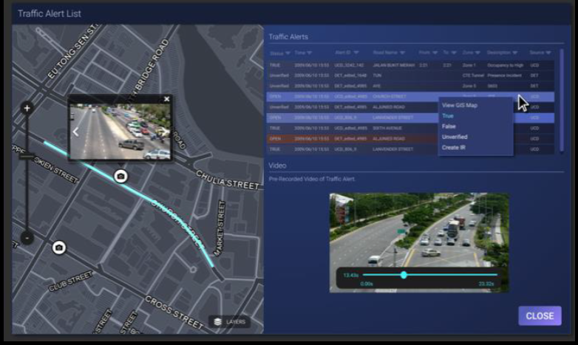

* 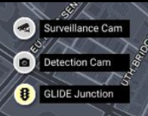

Todo :

CC grid view highlight one row

Traffic alert page right click menu need to resize

## August 01 2019

Chiann, Chiann with Chee Sung (4.00pm to 5.00pm)

Command control window page

1. Incident Record panel
   1. Show only 5 records and GIS map reflect 5 incident
   2. Road name data has changed remove PIE, Tun,
   3. Road name data has to change some other names.
2. Technical Alarm and work order graph data has changed to half the value of existing.
3. Traffic Alerts
   1. Remove “Zone” column
   2. “Source” data only has VA, DET
   3. If “Source” is VA then alert id start with CCTV_number
   4. The selected record changed Road name : CTE, Time: login time, status: unverified
   5. All the “status” column data has to be changed to “true”
   6. “Description” if the Alert id DET: Stopped Vehicle , UCD : Congestion
   7. “Alert ID” start with DET then source is DET
   8. “Alert ID” start with CCTV _ then source is VA
   9. The Selected incident must be the first record

GIS widnow display page

1. GIS map reflect all 5 incident put ICON in appropriate place
2. Layer Label has to change “TSpeed” to Link Speed
3. Layer Label has to change “DCam” to DETCam
4. Event few minutes change speed data layer

Accident IR Page

1. Cross Lane 3 and four 4 – make it red
2. Put only “Alert” and “Guide” Msg and remove “Jam” msg\
3. “Direction” toward TPE
4. “Type of Danger ” – add blank space
5. “Start point” and “end point” – same data
6. “Congestion End Point” – same data (using “start Point” value)
7. Change accident Icon to CTE Lane
8. On the Map
9. Video and new Message on the top and current message on the bottom need to display

Traffic Alert

1. Open from onclick event
2. Only one record has to show (selected record)
3. Remove zone column
4. Change the source start time, status, alert id, road name
5. Move traffic icon to lane 2
6. Show one accident video and 3 traffic alert video in near by cc TV location

Prediction Create new IR window for Prediction

Leftside - Map,

Right side - plan 1, plan 2, plan 3

On prediction view – current message and proposed message, traffic light sign

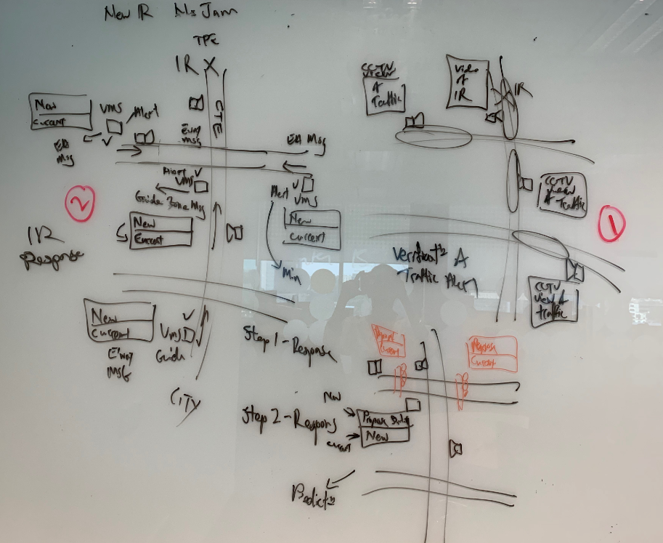

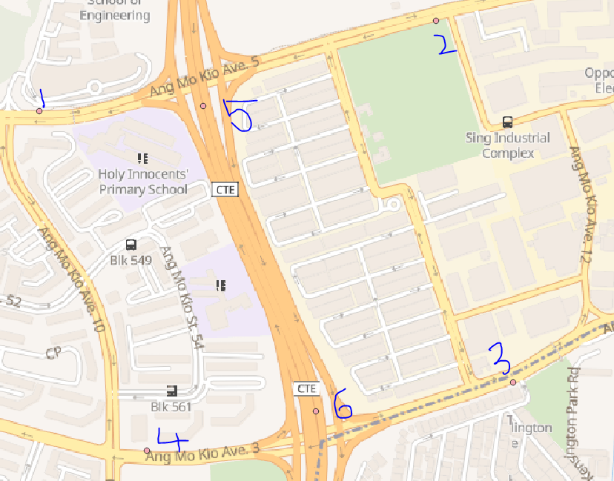

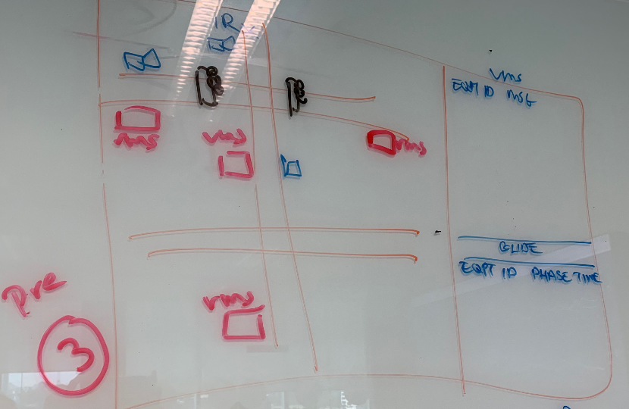

Mobile road work

1. Remove “Source” give “WorkType” water planting”
2. “State” - Plan
3. “Contractor name” - give fake name
4. “Vehicle number” – Give Singapore vehicle number
5. Remove Check box and label – Simulated, important VRS LTM”
6. Remove “Time” column from VMS Messages Response window
7. Show VMS two points before and two points after.

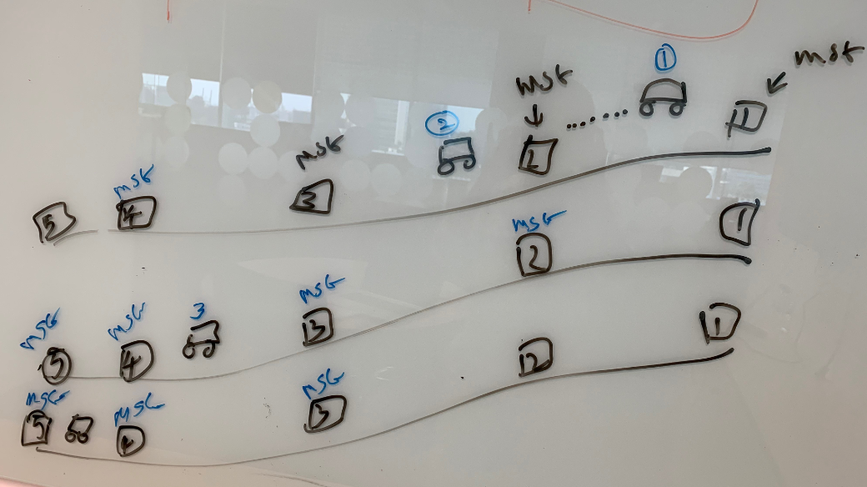

Here is the following todo work Priority based

1. BIS – graph speed
2. **GIS main window changes – Speed link layer and Incident Icon display.**
3. Mobile road work
4. Incident records

I have done the following functionality.

1. Accident Incident

The new incident (Accident) popup’s from the command control. The user views the accident location and corresponding video from CCTV and Detection camera next to the accident location. The system will generate the current and default message after the new incident on the map. It also generates the prediction information and gives two set of scenarios to overcome the traffic flow.

So the map has TIP, TTP, CCTV, Detection cam near the accident location.

1. Mobile Road Work

Complete the Planned event Mobile Road Work Task

## August 14

Chiann, Chiann with Chee Sung (11.15am to 12.05pm)

**GIS Map**

Detection Camera location is missing for SLE, BKE, KJE, PIE, TPE – expressway.

**Command Control**

1. Traffic Alert list in Command control – "status" has changed to True after choosing accident is true.
2. Road Name "CTE" color also changed to white
3. Traffic Alert list in Command control – “Description” changed to Congestion, Road Work etc but not in reverse direction

**Incident accident window**

1. VMS has pictogram on the message TIP
2. Change the TIP message new on top current on bottom
3. Add current and new message in TTP
4. When you “Implement all“ – show only new message in TTP with layer color, red, green, etc
5. Prediction plan 1 and plan 2 has same no of VMS messages.
6. Change prediction plan 1 and plan 2 messages.
7. Change Response panel “VMS” messages

Swapped

**Road Work**

Starting and endpoint added and point button and create line.

Show the first point VMS more seconds, remove 3 VMS if the vehicle reach 5 places

check mrw vms icon display arrangement, lanelayer display createaccbase.jp

Pending : Detection Camera Missing location for TPE, SLE, CTE, BKE, PIE, KJE.

VMS – TIP - TTP Messages

|  |  |  |
| --- | --- | --- |
| VMS | Default | Current / New |
| TIP (500201) | Null | Accident on CTE(SLE) aft Amk Ave 5 |
| TTP (800101) | Null | Accident on CTE(SLE) |

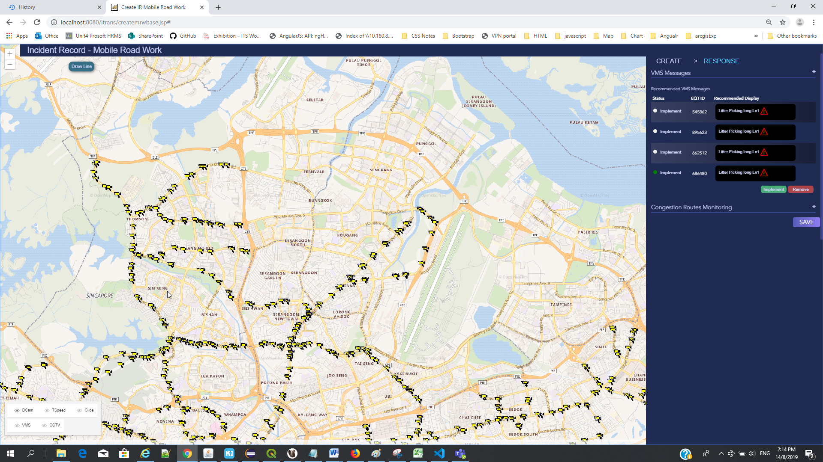

Min

Difference from CCTV and Detection Camera

